**DAY 5**

**EX-1**

package com.day5;

import org.openqa.selenium.By;

import org.openqa.selenium.WebDriver;

import org.openqa.selenium.WebElement;

import org.openqa.selenium.chrome.ChromeDriver;

import org.openqa.selenium.chrome.ChromeOptions;

import org.openqa.selenium.interactions.Actions;

import io.github.bonigarcia.wdm.WebDriverManager;

public class proj1 {

public static void main(String args[])

{

WebDriverManager.chromedriver().setup();

WebDriver driver;

ChromeOptions co = new ChromeOptions();

co.addArguments("==remote=allow=origins=*");

driver=new ChromeDriver(co);

driver.get("https://demoqa.com/droppable/");

WebElement drag1=driver.findElement(By.id("draggable"));

WebElement drop1=driver.findElement(By.id("droppable"));

Actions act = new Actions(driver);

act.dragAndDrop(drag1,drop1).build().perform();

driver.switchTo().frame(0);

driver.switchTo().defaultContent();

}

}

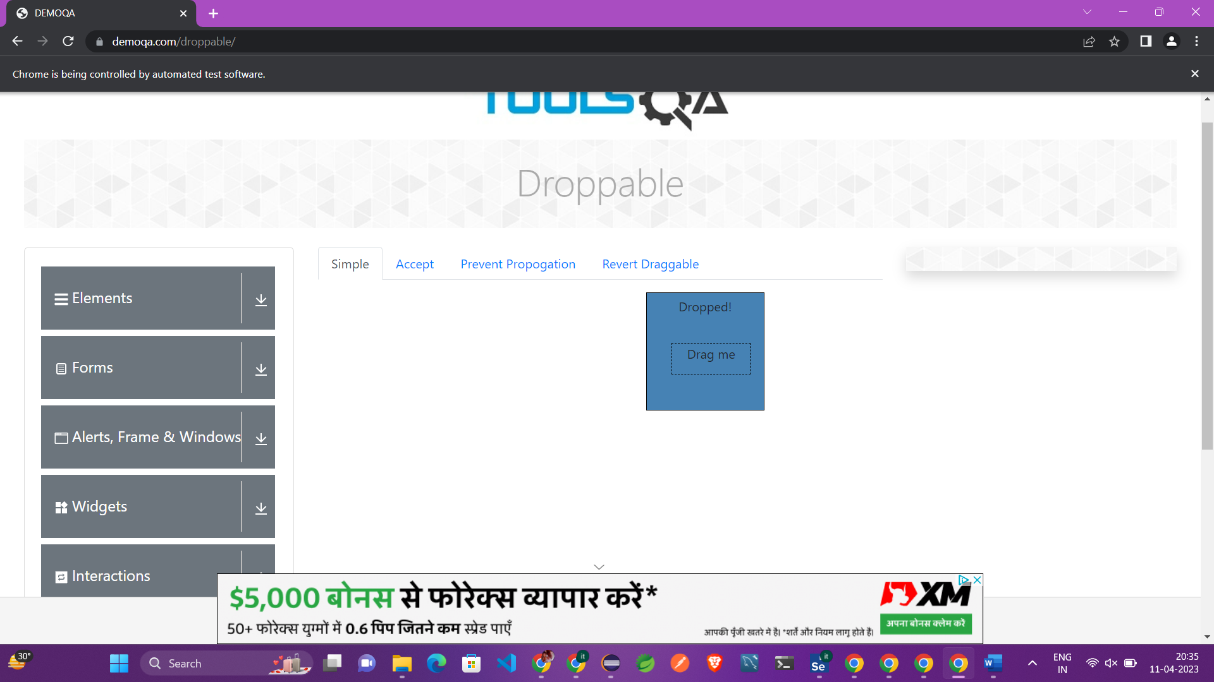

**EX-2**

package com.day5;

import org.openqa.selenium.By;

import org.openqa.selenium.WebDriver;

import org.openqa.selenium.WebElement;

import org.openqa.selenium.chrome.ChromeDriver;

import org.openqa.selenium.chrome.ChromeOptions;

import org.openqa.selenium.interactions.Actions;

import io.github.bonigarcia.wdm.WebDriverManager;

public class proj2 {

public static void main(String args[])

{

WebDriverManager.chromedriver().setup();

WebDriver driver;

ChromeOptions co = new ChromeOptions();

co.addArguments("==remote=allow=origins=*");

driver=new ChromeDriver(co);

driver.get("https://jqueryui.com/droppable/");

WebElement drag1=driver.findElement(By.id("draggable"));

WebElement drop1=driver.findElement(By.id("droppable"));

Actions act = new Actions(driver);

act.dragAndDrop(drag1,drop1).build().perform();

driver.switchTo().frame(0);

driver.switchTo().defaultContent();

}

}

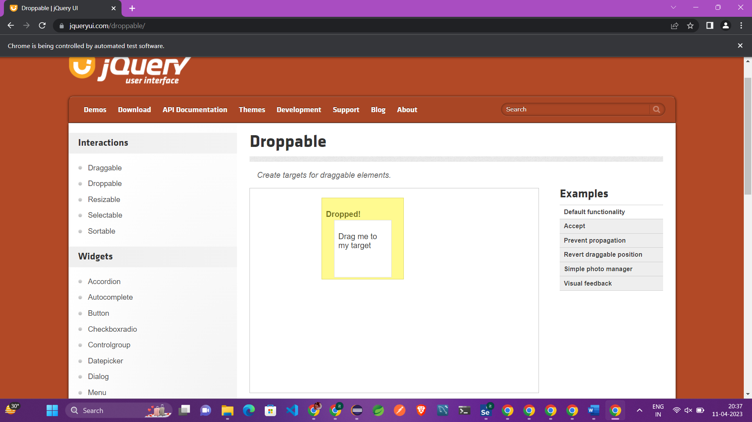

**EX-3**

package com.day5;

import org.openqa.selenium.Alert;

import org.openqa.selenium.By;

import org.openqa.selenium.WebDriver;

import org.openqa.selenium.WebElement;

import org.openqa.selenium.chrome.ChromeDriver;

import org.openqa.selenium.chrome.ChromeOptions;

import io.github.bonigarcia.wdm.WebDriverManager;

public class proj3 {

public static void main(String args[]) throws InterruptedException

{

WebDriverManager.chromedriver().setup();

WebDriver driver;

ChromeOptions co = new ChromeOptions();

co.addArguments("==remote=allow=origins=*");

driver=new ChromeDriver(co);

driver.get("https://demo.guru99.com/test/delete_customer.php");

WebElement CustomerId=driver.findElement(By.name("cusid"));

CustomerId.sendKeys("401");

WebElement submitBtn=driver.findElement(By.name("submit"));

submitBtn.click();

Alert alert1=driver.switchTo().alert();

Thread.sleep(3000); //paus pani start augum

alert1.dismiss();

CustomerId.clear();

CustomerId.sendKeys("402");

submitBtn.click();

Alert alert2=driver.switchTo().alert();

alert2.accept();

Alert alert3=driver.switchTo().alert();

String txt=alert3.getText();

alert3.accept();

System.out.println(txt);

}

}

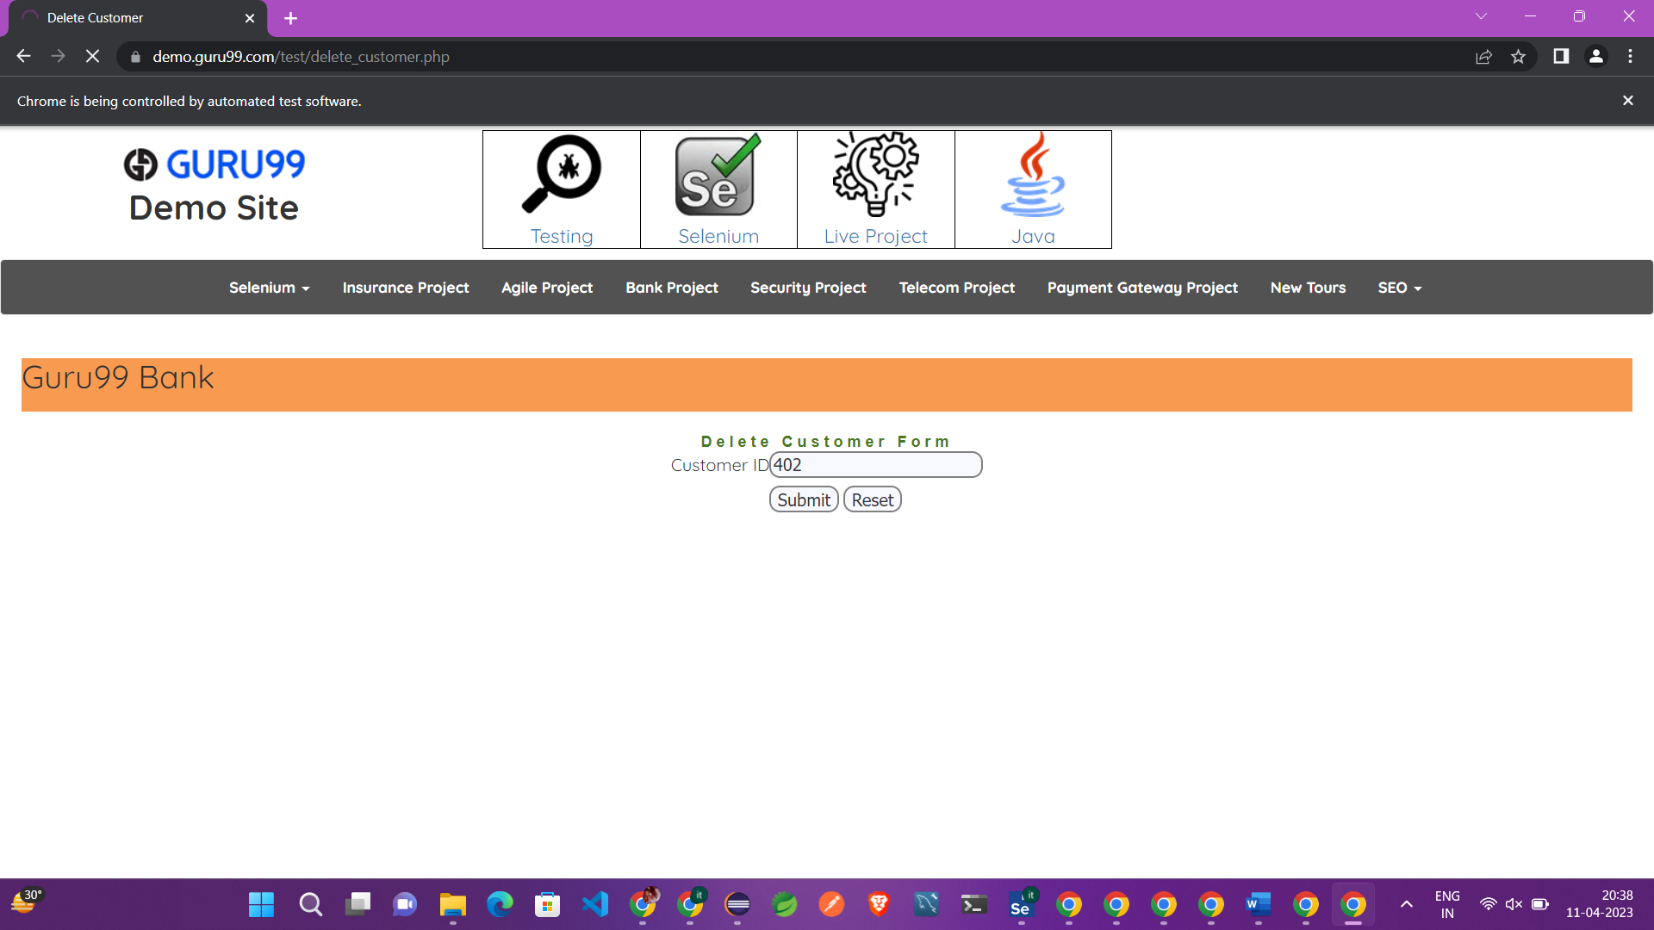

**EX-4**

package com.day5;

import org.openqa.selenium.By;

import org.openqa.selenium.JavascriptExecutor;

import org.openqa.selenium.Keys;

import org.openqa.selenium.WebDriver;

import org.openqa.selenium.WebElement;

import org.openqa.selenium.chrome.ChromeDriver;

import org.openqa.selenium.chrome.ChromeOptions;

import io.github.bonigarcia.wdm.WebDriverManager;

public class proj4 {

public static void main(String args[]) throws InterruptedException

{

WebDriverManager.chromedriver().setup();

WebDriver driver;

ChromeOptions co = new ChromeOptions();

co.addArguments("==remote=allow=origins=*");

driver=new ChromeDriver(co);

driver.get("https://www.abhibus.com/bus-ticket-booking");

WebElement from=driver.findElement(By.name("source"));

from.sendKeys("coimbatore",Keys.ENTER);

WebElement to=driver.findElement(By.name("destination"));

to.sendKeys("Dindigul",Keys.ENTER);

WebElement date=driver.findElement(By.id("datepicker1"));

JavascriptExecutor js=(JavascriptExecutor) driver;

js.executeScript("arguments[0].setAttribute('value','08/05/2023')",

date);

}

}

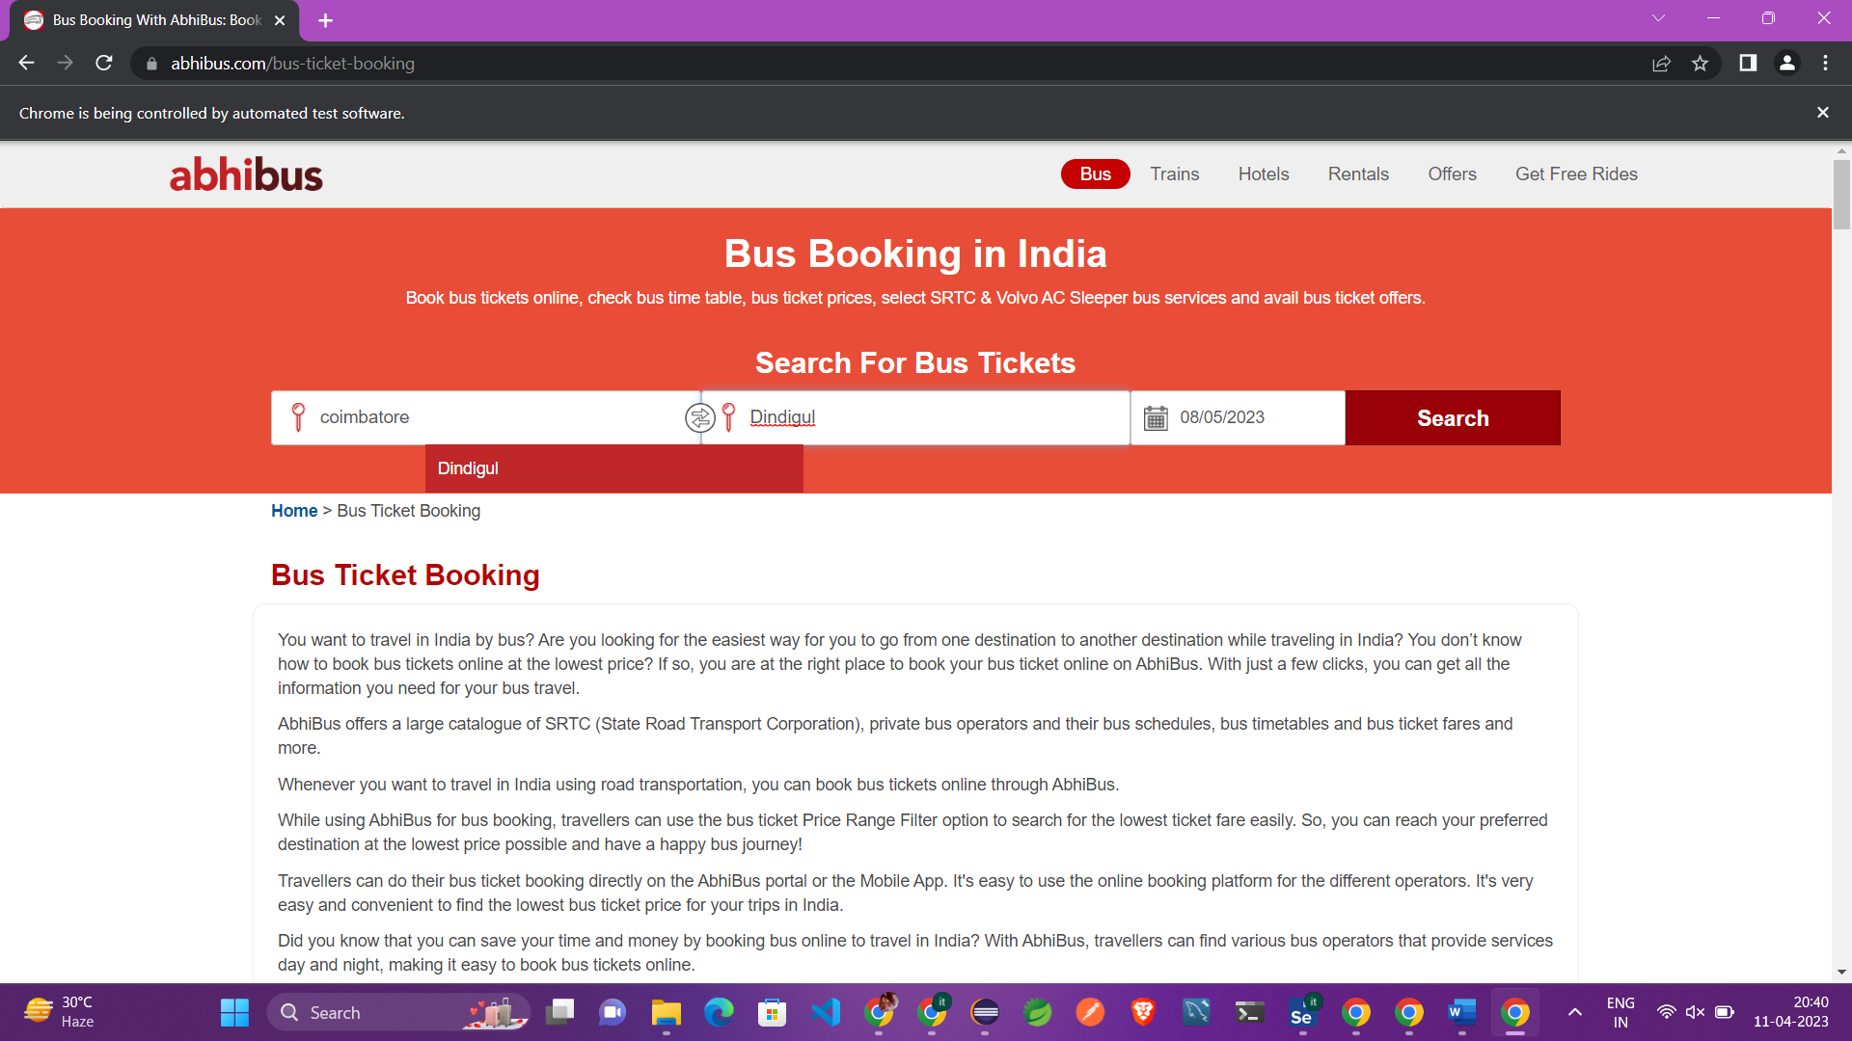

**EX-5**

package com.day5;

import java.util.Iterator;

import java.util.Set;

import org.openqa.selenium.By;

import org.openqa.selenium.Keys;

import org.openqa.selenium.WebDriver;

import org.openqa.selenium.WindowType;

import org.openqa.selenium.chrome.ChromeDriver;

import org.openqa.selenium.chrome.ChromeOptions;

import io.github.bonigarcia.wdm.WebDriverManager;

public class proj5 {

public static void main(String args[]) throws InterruptedException

{

WebDriverManager.chromedriver().setup();

WebDriver driver;

ChromeOptions co = new ChromeOptions();

co.addArguments("==remote=allow=origins=*");

driver=new ChromeDriver(co);

driver.get("https://www.google.com/");

driver.manage().window().maximize();

driver.findElement(By.name("q")).sendKeys("Apple");

driver.findElement(By.name("q")).sendKeys(Keys.ENTER);

String parent=driver.getWindowHandle();

System.out.println(parent);

System.out.println(driver.getTitle());

driver.switchTo().newWindow(WindowType.TAB);

driver.get("https://google.com/");

driver.manage().window().maximize();

driver.findElement(By.name("q")).sendKeys("Selinium");

driver.findElement(By.name("q")).sendKeys(Keys.ENTER);

//System.out.print("\n"+)

System.out.println(driver.getTitle());

driver.switchTo().newWindow(WindowType.TAB);

driver.get("https://google.com/");

driver.manage().window().maximize();

driver.findElement(By.name("q")).sendKeys("Cucumber");

driver.findElement(By.name("q")).sendKeys(Keys.ENTER);

System.out.print(driver.getWindowHandle());

Set<String>s=driver.getWindowHandles();

Iterator<String> I1=s.iterator();

}

}

